**Day 3 Lab Assignments**

1. Make a Navbar like the following:

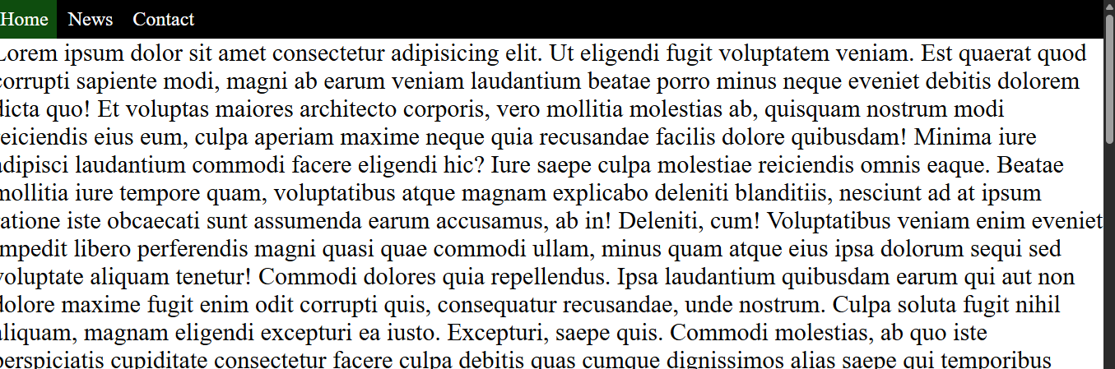

c. use inline because we want the list to be in the same line

I . inline :- Elements with display: inline do not start on a new line; they flow within the text content, occupying only the space required by their content

-Elements with display: block always start on a new line and take up the full available width of their parent container by default.

-Elements with display: inline-block behave like inline elements in that they do not start on a new line and allow other elements to sit alongside them.

1. 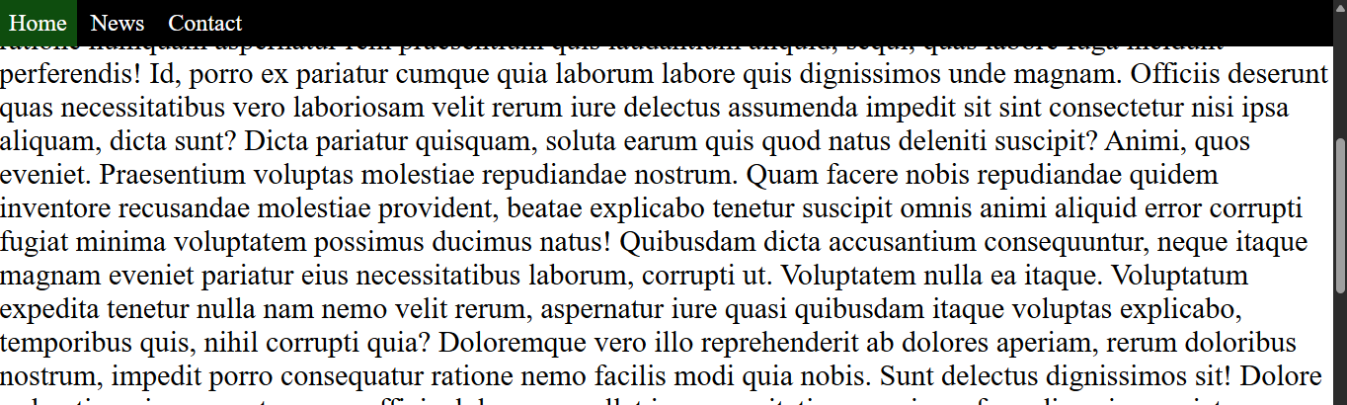
   1. Fixed :It stays in the same position on the screen even when the user scrolls
   2. Sticky : When the element reaches a specified offset it sticks to that position and stays fixed until another element with a higher z-index or the end of its containing block is reached.

